

|  | **CHARACTER BUILDING**  Academic Year 2024 - 2025  Semester 1 - Term 1 |
| --- | --- |
| Theme : Save Energy, Save Life Magic  Topic : I am a Sinner  **NOTE 1** | Name : ___________________________________  Student’s No : _________  Class : 5A / 5B / 5C / 5D |

**Consciousness**

1. **What is Consciousness?**

| * **Consciousness** is what helps us know what's going on inside and around us. It's like being aware of our thoughts, feelings, and actions. * It helps us **understand who we are** and lets us be present and aware of the world. * With consciousness, we can **think about what we do, make good decisions, and take responsibility** for our actions. * It's like a little voice inside that helps us **tell right from wrong**. * Consciousness also helps us **connect with other people** and understand their feelings. |
| --- |



### **Understanding The Origin of Sin.**

### All rules and instructions are made to make things better. It's important that everyone follows them so that there isn’t any confusion or chaos. Adam and Eve were special creations by God. They had the freedom to choose whether to obey God or not. They had work to do in the garden and rules to follow. They could have chosen to do the right thing, but the devil didn't like it when people obeyed God. The devil used a clever snake to trick Adam and Eve into disobeying God. The rules were there to tell them what to do. When rules are broken, there are consequences or punishments for those who disobey. Not only is there punishment, but things that should be good can turn bad. This is how it was with God too. When He created the world, He placed Adam and Eve in the Garden of Eden and gave them rules to live by. God said, “You can eat the fruit from all the trees in the garden, but you must not eat from the tree of the knowledge of good and evil. If you eat from it, you will surely die” (Genesis 2:16-17).

**Joseph Avoided Sin**

There are six key moments from the story of Joseph avoided sin: 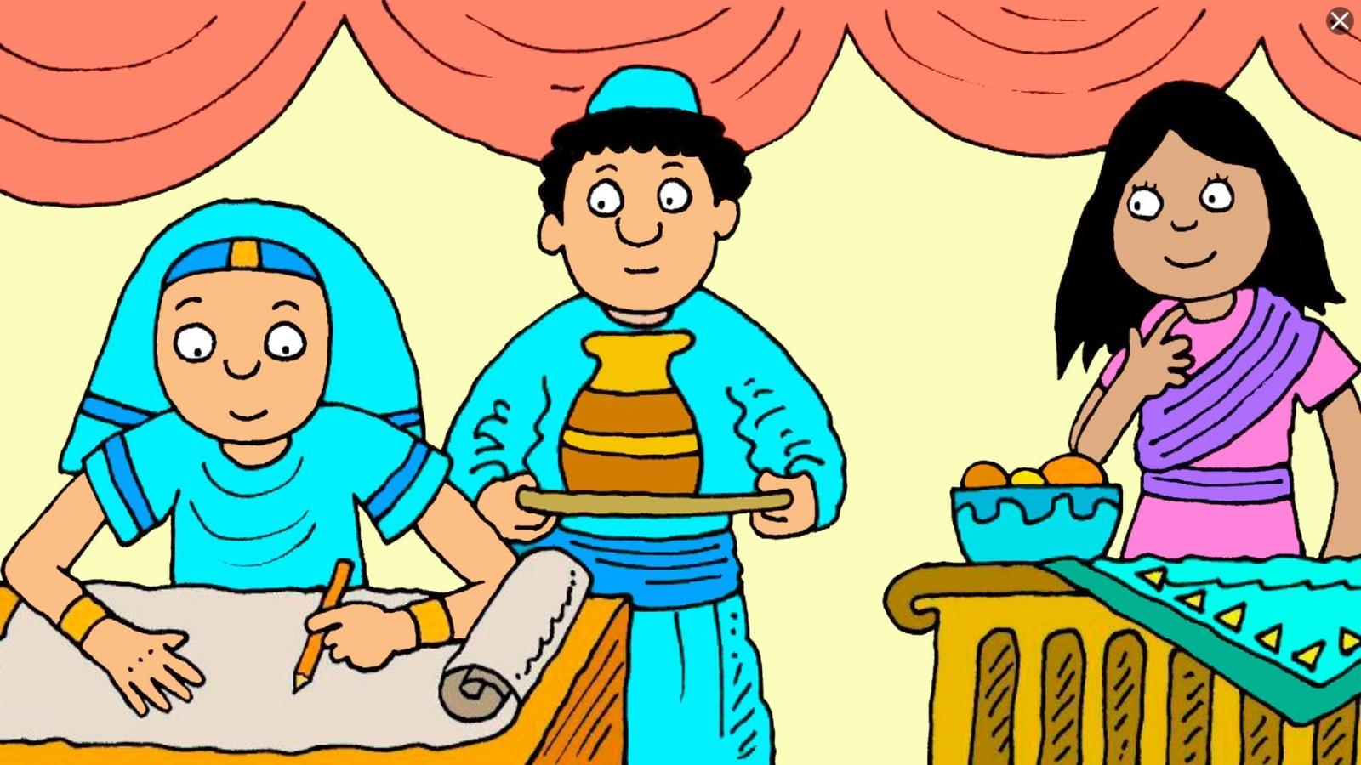

1. **Joseph in Potiphar’s House:**
   * Joseph working diligently as a servant in Potiphar’s house, demonstrating his loyalty and trustworthiness. 
2. **Potiphar’s Wife Approaches Joseph:** 
   * Potiphar’s wife trying to tempt Joseph by holding onto his cloak, while Joseph tries to keep his distance.
3. **Joseph Refusing the Temptation:**
   * Joseph firmly refusing Potiphar’s wife, explaining that it would be a sin against God and his master.
4. **Joseph Running Away:**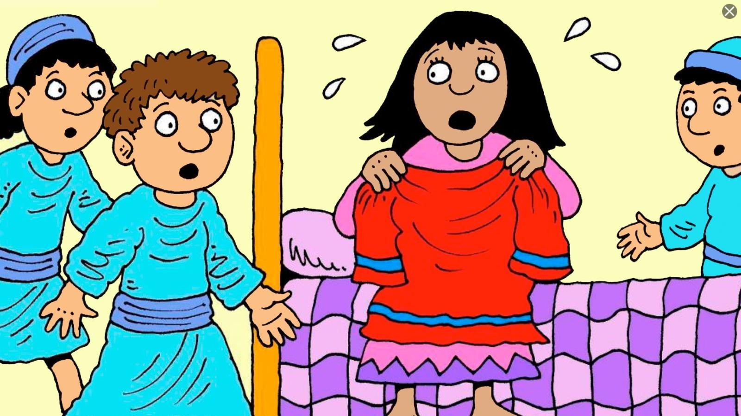
   * Show Joseph fleeing from Potiphar’s wife, leaving his cloak behind as he runs out of the house.
5. **Potiphar’s Wife Accused Joseph:**
   * Potiphar’s wife holding Joseph’s cloak and falsely accusing him of trying to harm her.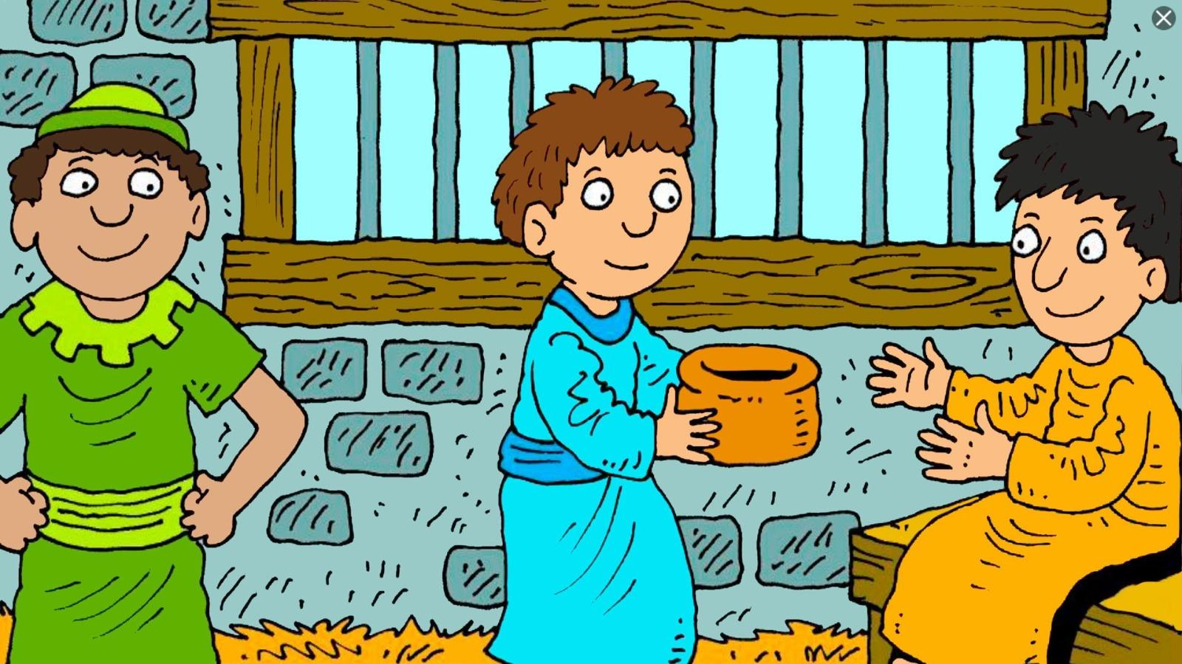
6. **Joseph Being Thrown into Prison:**
   * Joseph being taken away and put in prison, yet remaining faithful to God despite the false accusation.

